*The Committal will take place after the service in church.*

*Everyone is invited to join Norma’s family at Walton Lea*

***or*** *go straight to the Hall*

*which is the single-storey building in the church car park.*

*Tea and coffee will be available immediately after the service*

*and the reception will begin as soon as the family returns*

*from Walton Lea.*

St Andrew's Church

Orford with Longford

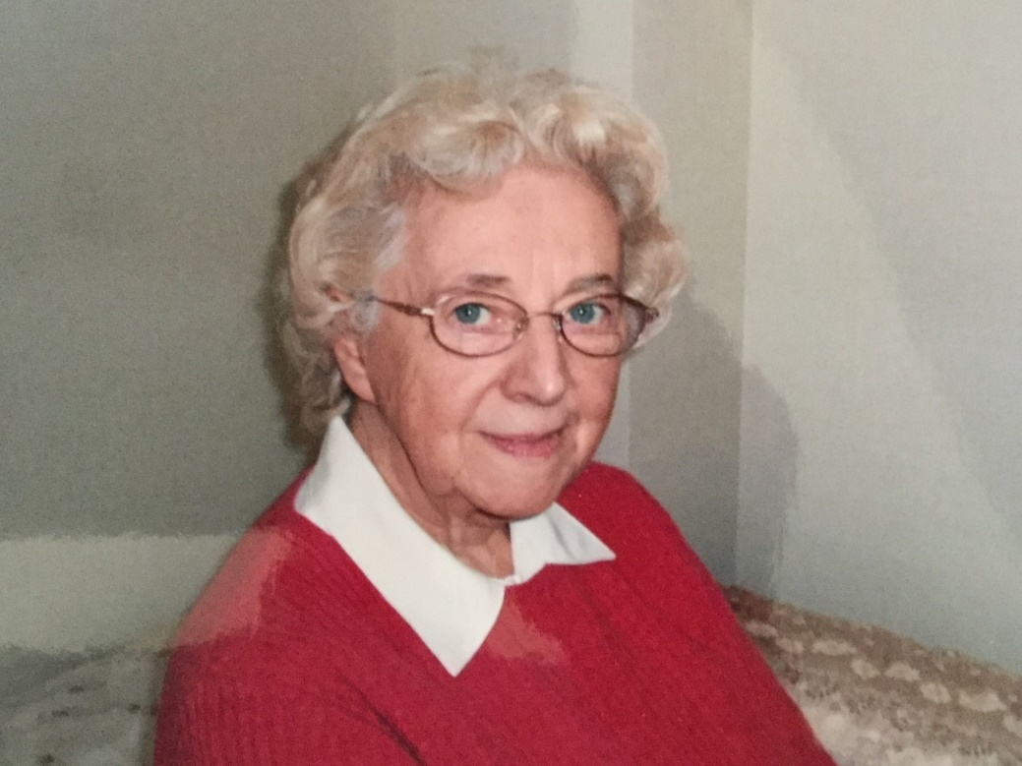

A Requiem and Celebration of the Life of

Norma Lee

4th April 1933 to 26th October 2019

Thursday 14th November 2019